Living and Non-Living Organisms Unit

K-1 Grade Level
- Introduction and Overview
Statement of Topic:
Living and Non-Living Organisms is a necessary part of early childhood/elementary classes in that it teaches children about their world and themselves and how various objects present in their life are labeled ‘living’ and ‘non-living’ and what factors lead to the various objects being labeled by either.
General Unit Description:
This unit is a set of complete lesson plans that teach various factors and parts of living and non-living things in an entertaining and stimulating way that grasps the short attention spans of young children, yet presenting the information at a level that young children will understand and grasp fully when all has been said and done.
Content of Unit:
- Unit Map
  - Goals
  - GLCE
  - Lesson overview and objectives
- Lesson plans in Sequential order
  - Is it Alive?
  - Gone Froggy!
  - Adventures in the Rainforest
  - What’s the Point of That?
  - The Ecosystem
  - My Body
  - Dinosaurs, were they real?
  - Conclusion: Wrapping up!
- Strategies and Materials Used/Resources
- Assessment ideas
Description of Students:
Kindergarten and First graders come from an assortment of backgrounds and enter the classroom with prior knowledge and personal understanding on subjects. They will not be afraid to share what they know, and keep you busy answering their unrelated questions. They are easily distracted and must be kept actively engaged while learning. Messes will occur, but that is a fact of life, in the famous words of Ms. Frizzle, “get messy and make mistakes,” its how children learn.
Time allotted for Unit: 30-45 minutes per lesson.
- Rationale
Value of Lesson to Students:
This unit teaches young children how to think critically about what they believe and what is true in relation to living and non-living things. Children use the information to create new knowledge that they file away into what they knew prior to the lesson, and gain new insights and understanding. Children will also learn how to sort information into parts and understand each set of information through visual aids and hands on activities prevalent throughout the entire unit.
How it fits the needs of Students:
All young children are inquisitive, growing up we were constantly stopping during walks to check out the flowers, rocks, bugs, dirt, and leaves. Each new thing was important to us and part of how we developed. We asked questions as children today ask, questioning; Who, What, Where, When, and the all important, Why?
This unit allows children to become inquisitive learners and to explore the various aspects of living and non-living things and how this topic relates to them, not only in environment, but also physically and mentally. We believe that children learn through interactive activity and play, thus we meet the physical need of the child, we also believe that children build knowledge mentally through retrievable for later use.

Relation to Real-World:

As stated above, children need to know about living and non-living things because they will be in contact with many objects that fall within this category including their own person. Children need to know about the environment and how to become the caretakers of God’s creation. To do that they must first understand creation and the various aspects of creation that fell under our unit topic.
Children get a chance to relate this to real life in that they will be able to take an assignment home and see how the object changed or didn’t change based on the different environments it resided in while out of the classroom for a week. The objects also used to teach this unit, were related to things that children were in contact with on a regular basis or had read about from various books and stories.

Reflection on your teaching philosophy:

We all believe that children learn best when given situations and environments where they are actively and physically engaged through hands on activities and visual aids, this philosophy comes a lot from the theory represented by Piaget; Social Constructivist. He wrote that children learn best in environments where they learn from inquiry based on their own discovery and through peer discussions and engaging activities where the teacher is the facilitator and not the authority.
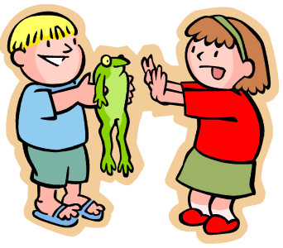
Teaching science allows us to integrate this theory and our philosophy into the classroom and aid in the cognitive development and growth of our students.

- Unit Map

LIVING AND NON-LIVING CONCEPTS

UNIT MAP

GOALS: In sequence with the Michigan Standards and Benchmarks and the Science GLCE’s Draft, this unit seeks to:

“Identify, compare and contrast living and non-living things”. (L.OL.00.20)

By the end of the unit, students should know:
- What it means to be alive or not alive
- How animals and plants are living things and have a life cycle.
- How ecosystems are part of the life cycle in animals, plants, and humans.
- Through creativity and hands on learning find out about themselves as a living thing.



Lesson # 1: Topic IS IT ALIVE?

Objective: TLW Identify and compare living and non-living things

Objective: TLW Tell what a living organism needs to survive.

(Ex. Food, air, water, sunlight, habitat etc.)

Description: Through the use of different objects and learning tools, the children will classify what is living and what is not. They will then discuss what it takes to survive as a living organism.
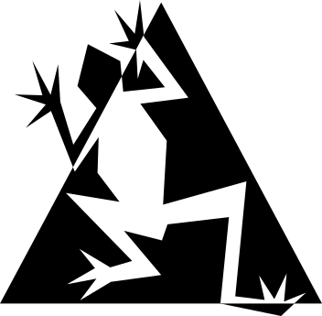

Lesson # 2: Topic GONE FROGGY

Objective: TLW Describe the life cycle of a frog

Objective: TLW Explain characteristics of a frog

Description: Through visual aids hands on projects and handouts, children will find out about frogs, how they grow, and some of the characteristics of a frog.

Ex. (Eggs, Tadpole, Froglet, Frog) (Long sticky tongues, webbed feet, and strong back legs for jumping)

Lesson # 3: Topic Adventure in the Rain Forest

Objective: TLW Describe the basic requirements that are needed for living things to survive.

Objective: TLW Discuss positives and negatives of humans on the rainforest.

Description: While taking an adventure through the rainforest, the students will understand what ALL living things NEED to survive. They will also learn what the current status is on the rainforest and what humans have to do with it. Is everything they are doing to the rainforest good for it or is some of it harming the rainforest?
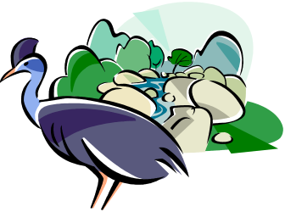

Lesson # 4: Topic WHAT’S THE POINT OF THAT?

Objective: TLW Compare and Contrast familiar organisms on the basis of

visible characteristics.

Objective: TLW Explain functions of a plant: root, stem, flower, fruit, & seeds.

Description: In the previous lesson students will create gardens using plastic baggies and wet towels. This lesson shows how different factors play a key role in the growth of plants. The student’s will see how their beans have grown roots over the week and discuss what happened. They will also learn about the different parts of a plant.





Lesson # 5: Topic THE ECOSYSTEM

Objective: TLW Explain whether an ecosystem needs both living & non-living things
Objective: TLW Describe the needs of an ecosystem

Description: As the students look at different ecosystems around the United States of America the students will be able to answer whether an ecosystem needs both living and non-living things and to answer this question they will then be able to explain what an ecosystem needs.
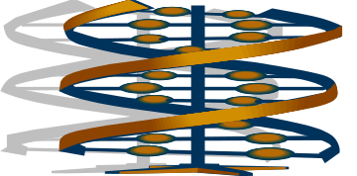

Lesson # 6: Topic MY BODY

Objective: TLW Create a replica of their body on the inside.

Objective: TLW Recognize that they have similar characteristics of their parents and be able to name some of the similarities.

Description: The students will receive a pair of lungs, heart, stomach, and other inward body parts, and learn about where these are located in their own body. They will use large scale drawn bodies and then tape the correct body parts to the correct area of location.

They will color their bodies with different colors that represent the features they inherited from their parents.

Lesson # 7 Topic DINOSAURS, WERE THEY REAL?

Objective: TLW Explain how fossils tell about the past and are created (and Noah’s Ark) (From a Christian Standpoint using Ken Ham material)

Objective: TLW Explain how physical and behavioral characteristics of animals help them to survive in their environments.

Description: Children will learn about dinosaur fossils and how they relate to the Christian faith. Were there dinosaurs in Noah’s Ark? What happened to them? We will be using Ken Ham’s material to teach this.

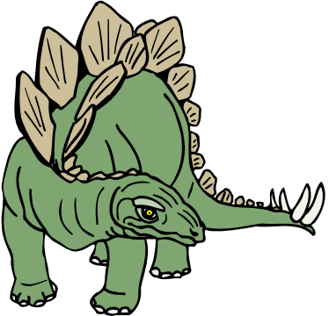
The children will learn how different dinosaurs were protected from predators by the way they were created.

Lesson # 8 Topic CONCLUSION: Wrapping up Life

Objective: TLW Rephrase what all living things need to maintain their existence

Objective: TLW Recall the difference between living and non-living organisms

Objective: TLW Classify organisms and animals based on their characteristics

Description: A review of everything learned in the past seven lessons that deal with living and non living beings. And how what we learned affects how we live and what we will do in the future concerning living things.

- Instructional Strategies and Materials
LESSONS 1-8

Lesson # 1

Topic: WHAT DOES IT NEED TO BE ALIVE?

Subject/Grade Level: Science Kindergarten-1st grade

Concept: The difference between live organisms and not alive objects.

Rationale/Purpose: All things on earth can be categorized as either live or not alive. Understanding this difference is one of the first steps to understanding the world around us. Students must understand this categorization before they can understand many other parts of their world.

Objectives:

TLW Tell what a living organism needs to survive.

(Ex. Food, air, water, sunlight, habitat etc.)

TLW Design a system that encourages growth of plants

Background content: As a teacher you will need to have a full understanding of the main processes that classify life. You will need to know what objects have life and how that is defined. You will also need to know what plants need to thrive and why those are needed. Your understanding of this must be at a level where you can translate it to a kindergarten level of understanding.

Concepts being taught: Live, and not alive are the only concepts being taught other concepts are used but most of those are concepts that the students would have learned previously.

Materials:
- 2 boxes for each group, one labeled “Live” and another labeled “Not alive”
- Pictures of many different objects and organisms. Some alive and others not alive for each group
- Fast Plant seeds
- Water
- Dirt
- Clear 8oz drinking cups
- Popsicle sticks
- Marker
- Paper
- pencils

Strategies and Activities

Engage: Ask the students… “Who here has ever seen a frog?, Who has ever seen a live frog?, How about a frog that isn’t alive? Was it dead or something else? How about a stuffed frog is that alive? I want you all to show me what you think is alive and what is not alive.

Explore: There are two boxes on each of your tables. I want you to work in groups and sort out the object pictures I give you into two groups. If your group decides the object is alive put it in the live box, if it is not alive I want you to put it in the not alive box. Take all the time you need and discuss your answers with your group until you come to a decision you all agree on. If you don’t know take a guess and we will discuss it later.

Explain: Make a chart on the board of each object and list where each group decided to put that object. After each object is categorized discuss why objects were put into each separate group. Why are these alive and these are not. Get the student’s ideas. Use leading questions to get answers on things such as live things eat, breath, grow, reproduce etc. After this is discussed go back and visit the objects on the chart which were debated or differed from the correct answers.

Elaborate: Now that the children have a basic understanding of what is alive and not alive as well as why have them implement their understanding by creating a working habitat for a plant to grow in. Ask them as a group to come up with what they think they will need to make a seed they will be given grow. Have them write up a list of what they will need. Compare that list with the other groups. When a class consensus is reached pass out the materials they requested. They should be dirt, water, sunlight, and a cup. Have enough for each student to make their own. Write their names on a popsicle stick to put in the cup so they know which plant is theirs.

After the seeds are planted ask the students what they could do to see if everything they did for their plant was necessary. One student will hopefully come up with the idea of taking away certain variables from different plants to see what the result will be. If they don’t suggest this use leading questions to get them to this point. Set up several other plants: one which has everything except sunlight, one which is never watered and one which is placed in water by the sun but has no dirt. The students will be able to observe what happens to these plants different from theirs.

Evaluate: Have the students keep journals of their plants growth. Have them draw pictures each day or each couple of days of the progress their plants have made and make predictions of what will happen to the plants that are missing essential elements. At the end of the unit have the students turn in their journals to see if they understood why some plants lived while others did not.

Plans for individual differences: Each of the different learning styles is touched on in this lesson which will help all students find something in this lesson that will help them learn at their best. Because this project is done in a group the students who have learning disabilities can get help from their other group members and the students who are more advanced will be able to help the others in their group. By giving them leadership roles they will be able to stay more focused and not get bored by the project.

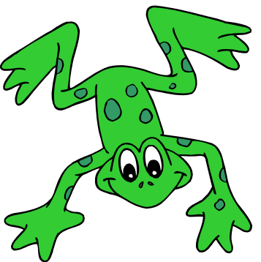
GONE FROGGY!!!!

Lesson # 2 for Living & Non-Living

Grade Level: K-1st
Concept: Living and non-living frogs, what are the differences?

Purpose:
To teach children about living and non-living organisms by looking at frogs; both real and stuffed toys, and seeing what makes one a live and the other not.

Standards & Objectives:
Strand # 3 Using Scientific Knowledge in Life Science, Standard III.2 The Organisms of Living Things.
Benchmarks
# 3 Describe life cycles of familiar organisms
TLW – Describe the life cycle of a living organism (Frog)
# 1 Explain characteristics and functions of observable parts in a variety of animals.
TLW – Explain what Characteristics make a Frog live instead of not alive

5 E Lesson Plan

Engage:
(Begin by having the little ones come into the classroom and grab a felt lily pad and a snack from the table to sit on and eat during reading time, and have them go over to the predetermined circle and sit down on their lily pad.)
“Good morning, my name is Miss Hartwell and I will be reading you a story, how many of you know the stories about Froggy? Wow! Quite a few of you have read about Froggy. Well, Today, we are reading “Froggy Gets Dressed” I want you to all listen carefully because the story is going to give us clues about what we are going to learn today, I also need you to say “what” when I say “froggy!, can you do that? Okay.”
(Read Story)
“How many of you like that story? It was very funny wasn’t it? How many of you think you know what we are going to learn about? Wow! Well don’t tell me yet, we are going to play a game and afterwards you can tell me what your answer was and we will see if you were right or on the right track.”
“I need everybody to stand up,”
(Have everyone stand up)
“When I say okay, I want you to pick up your lily pad and put it back on the table and then get into groups of three or four and go over to where start sign is point) and hop in place like a frog.”
(They will be at the starting position for Froggy-land.)
“Okay”

Exploration
“How many of you have played Candy land before?” Well today we are going to play a game very similar to Candy-land, only we call it Froggy-land. You will get cards just like in Candy-land and move as a group to either one or two colored spaces.(Show cards) Only our squares are lily-pads and you are going to have to hop from one to the other like a frog.
There are cards in Froggy-land that are similar to Candy-land.”
(Show cards for Mr. Plum, Queen Icing, and then the Bog, Characteristics, Life cycle, and Black dots)
“When you get any of the special cards that means you move to those spaces and get to do different activities while waiting for your next turn. Does that sound like fun?
(Explain activities at the all the stations, i.e. Bog – learn about what living frogs eat and their habitat and have students catch as many flies as they can, Life Cycle – learn how living frogs grow and then show how life cycle of non-living frogs.-students will spin wheels to see different picture, and make their own spinner. Characteristics – by looking at a real frog try to figure out what makes it a frog and alive)
Who is ready to play? Alright lets begin, everyone needs to line up neatly and remember when you pick your card you need to hop to your colored lily pad. Let’s play!”
(Play game; if time is becoming of the essence take out the black spot card and single colored cards; make sure everyone makes it to all the stations.)

Explanation
“Alright did everyone have fun? Good, well let’s grab our lily pads and go back to our circle.
(Everyone grabs pad and sits down)
(Question time)
“What are some things you learned about today?
What can you tell me about frogs that aren’t alive?
What can you tell me about frogs that are alive?
Who thinks they know what I wanted you to learn about today?
(Different things that are part of living animals)

Evaluate
You guys all did a great job today, but before you leave I want you to meet a special friend of mine. (Take frog out of case) His name is Froggy; does he look anything like Froggy from our story? Or from what we learned today, No, Why?
Well I am going to hold Froggy and any of you who would like to pet him or hold him may before we leave for today.

Elaborate – this will be done on the last day

Materials:
Froggy Land pattern for Set Up
Felt Lily Pads
Various Construction Paper Lily Pads
(Label one lily pad, Bog, Characteristics, and Life Cycle, and Black dot)
Index Cards with lily pad colors
Candy-Land cards
Life Cycle Wheels
Characteristic Chart
“Froggy Gets Dressed” Story
Mini wading Pool
Frogs and Flies pattern
Double sided sticky tape
Ants on Logs or Frogs on pads snacks
Real Frog

Start
Finish
FROGGY
BOG
BOG
FROGGY LIFE
Life
WHAT FROGS HAVE
What Frogs Look Like
Go to Bog

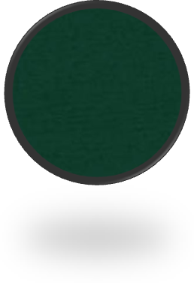
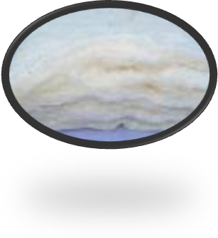
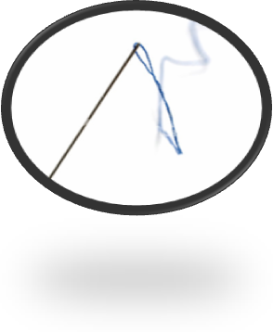
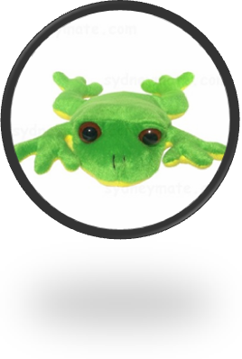
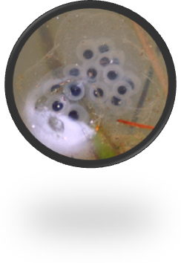
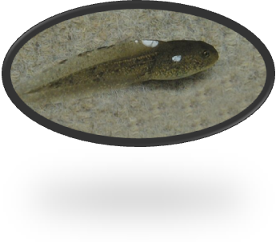
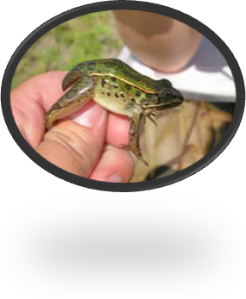
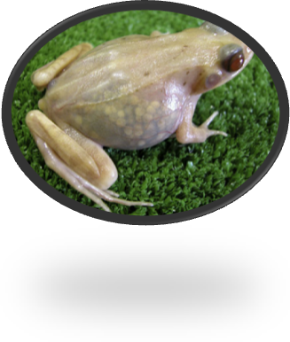

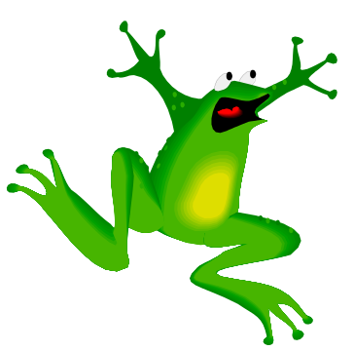

FROGGY RESOURCES
FROGGY RESOURCES

BOOKS….

Slippery, Slimy Baby Frogs……………………………Sandra Markle
Starting Life Frog…………………………………......Claire Llewellyn & Simon Mendez
Growing Frogs………………………………………...Vivian French
From Tadpole to Frog…………………………………Shannon Zemlicka
Frogs Sing Songs………………………………………Yvonne Winer; Ill. Tony Oliver
The Life of a Frog……………………………………...Clare Hibbert
Classifying Amphibians………………………………..Richard & Louise Spilsburg
Flashy, Fantastic, Rain Forest Frogs………………….Dorothy Hinshaw Patent
What is an Amphibian?...................................................Bobbie Kalman

Websites with Worksheets and Activities….
http://www.kidzone.ws/lw/frogs/ws7.htm
http://jas.familyfun.go.com/crafts?page=CraftDisplay&craftid=11117
http://www.dltk-kids.com/animals/m-wordsearch-frogs.htm
http://www.familyfun.com

Title:
- Adventure in the Rain Forest

Subject/Grade Level:
- Living vs Non-living
- Kindergarten – 1st Grade

Rationale/Purpose:
- It is important for the students to know what they need and what their pets need to survive.
- Standard III.5- Ecosystems

Objectives:
- The students will be able to describe the basic requirements that are needed for living things to survive.
- The students will be able to identify the four layers of the rainforest.

Content:
- The rainforest is made up of four layers which each contain living and non-living things.
- Label and describe the four layers of the rainforest= Floor, Understory, Canopy, and Emergent
- Describe a few living and non-living objects that make up each of the four layers

Materials:
- A big parachute
- A big painting of the rainforest (the different levels)
- Placemat of a picture of rainforest (with different levels)

Strategies and Activities:
- Engage
  - All of the students will get into one big circle, each holding on to the big parachute
  - We will first put the parachute down to the floor, then we will bring it to our knees, then to our head, and finally we will lift up over our head as far as we can
- Explore
  - The students will get into groups of 3 or 4 (those they are sitting with)
  - As I hand out the placemat pictures of the rainforest that includes all four layers and the individual clip art pictures of living & non-living things (rock, dirt, nest, ants, mice, snakes, leopard, spider monkeys, fruit bats, butterflies, fruit, toucan, parrot, sunlight) to the groups I will explain the directions to them
  - They are to take the clip art pictures and place them on the placement where they think they belong: how high or how low in the rainforest they live and whether they are living or not living
- Explain
  - Come back together as a class
  - Have the individual groups tell me where they placed each of the clip arts… I will then place them on the big felt board which will be in the front of the class
  - When the students don’t agree (teachable moment) ask why they placed it in that location and why they did not.
  - If there is a conflict of Living or Non-living: Ask the students What if it was placed in a bag with no air? What if it had no water? What if it had no food to eat? Make sure to express the ideas of it needing air, water, and food to survive
  - The trees of the tropical rain forest provide shelter for many animals, such as birds, monkeys, cats, butterflies, insects, snakes, and frogs. Because most trees in the rain forest are very tall, they are equipped to hold many different animals. Some animals live at the bottom of the trees, where it is dark and damp. Others live towards the top of the trees where it is light.
  - Explain the four layers of the rainforest
    - emergent layer
      - the treetops (get a lot of sun)
      - only the tallest trees make it this high
      - is where the treetops join together to form the roof of the forest
      - harpy eagle, toucan, parrot, nest, and sunlight
    - canopy
      - under the leaves of the trees
      - bright and colorful
      - spider monkeys, fruit bats, tree frogs, butterflies
    - understory
      - above the dirt of the floor
      - darker b/c the tree tops keep the sun out
      - plants have to grow large leaves so that they can reach the sunlight
      - lizards, snakes, jaguar, leopard
    - forest floor
      - is the ground.
      - Darkest and wettest part of the forest
      - Very little sunlight can get to this part
      - Almost no plants b/c they can not grow
      - Dirt, rocks, ants, mice, anteaters
  - we sing the “Layers of the Rainforest Song”
To the Tune: If You’re Happy and You Know It
There are 4 layers in the Rainforest
4 Layers
There are 4 Layers in the Rainforest
4 Layers
Forest Floor, Understory, Canopy, Emergent
There are 4 layers in the Rainforest
4 Layers
  - We will go through lifting the parachute and singing the song two more times
- Evaluate
  - Through the class discussion, pay attention to the students responses
  - Evaluate whether the students are understanding it or not… make sure all the students are participating and putting forth their own input
  - To make sure they understand the living and non-living aspect, orally list off things in their own community and have them tell whether they are living or non-living… encourage them to go through the questions whether they need food, air, and water.

Plans for Individual Differences:
- If there are some struggling students in the classroom, make sure to group them with a stronger student.
- The activity includes hands on and verbal.

WHAT’S THE POINT OF THAT? Lesson 4

Science: What makes living organisms different from each other and why do they have those parts.

Kindergarten/first grade appropriate

Rational/Purpose: By knowing this information the students will be more aware of the living organisms around them and have a better understanding of parts of those organisms.

Objectives:
- TLW Compare and contrast familiar organisms on the basis of its visible characteristics.
- TLW Explain functions of a plant: root, stem, flower, fruit, & seeds.

Content
- As a teacher you should fully understand the functions of major parts of living organisms including plants as well as animals. You should have a clear understanding of how organisms differ from each other as well as how they are similar.
- Concepts being taught: Parts of living things; body/stem, leaves/skin, roots/veins.

Materials:
- One picture of each of the following living organisms for each group including; a snake, spider, dog, flower, tree, and bird, rock
- Green pipe cleaners, brown yarn, construction paper, felt leaves, tissue paper petals
- Pencils
- Lined paper
- Glue
- Medium yellow pom

Strategies and Activities

Engage

Start by reminding the students of what they learned about living things previously. Then ask them if all living organisms look the same. They should answer no. Ask them if they think that living organisms have things in common though about the way they look. The answers may be varied here.

Explore

Pass out the seven different pictures to the students who should be broken up into small groups of about four students. As a group have the students point out things that are the same or different about pairs of pictures. Make sure they come up with at least one similarity and one difference between the plants and animals, as well as the plants to each other and the animals to each other. All the similarities and differences should be related to how the organisms look.

Explain

After all the groups are finished making as many visual connections as possible between the seven different pictures make a complete list of all the groups thoughts together. Put this list on the board so everyone can help build it. Discuss the similarities they made as well as the differences they noticed. Use leading questions to add connection which may be missing, or to help fix misconceptions.

Explore

After the students have realized what similarities and differences different plants and animals have to one another they need to learn why they have these differences. Give the students each a green pipe cleaner, a yellow pom ball, some petal shaped tissue paper, some felt leaves, yarn for roots and a piece of construction paper. Explain to the children that they need to use the materials provided to create a flower. Do not explain which part goes where, that is for them to decide. Also tell them that they need to label each part as they glue it onto the paper. Pass out the glue and pencils and let them go at it. After it is glued on and labeled let them make predictions of what each part is for.

Explain

Again have the groups share what they decided together. Show them how you put your flower together by drawing a picture of the flower on the board. Together as a class have the class label each part of the flower and then make a list of predictions of what each part is for. Use leading questions to try and get the correct answers out of the students. Encourage students who are one the right track to elaborate on their thoughts. Eventually by the end the students should know the basic functions of each part of the flower either by figuring it out on their own or by you giving them concept words to learn and understand.

Evaluate

After the assignment, have each student write down three different things they learned in science that day on a 3X5 card to turn in. This way you will know what was learned and what they are still a little fuzzy on, so that you can elaborate on it more in the next lesson of the unit.

Plans for individual differences: This lesson plan hits on the three major learning styles including visual, aural, and kinesthetic. It is also done in a group so any student who is struggling should be able to get help from one of the other students in their group. No real changes should need to be made for most students no matter their difference.

Title:
- Lesson #5: The Ecosystem

Subject/Grade Level:
- Living/Non-living
- Kindergarten-1st

Rationale/Purpose:
- Because all of the students live in an ecosystem, it is important for them to know the needs of an ecosystem and what it needs in order to survive.
- Standard III.5- Ecosystems

Objectives:
- The students will be able to explain whether an ecosystem needs both living and non-living things.
- The students will be able to describe the needs of an ecosystem.

Content:
- For an ecosystem to survive, it needs both living and non-livings things. These things all work together to ensure the survival.

Materials:
- Provided Handout

Strategies and Activities
- Engage:
  - Ask the students to think about the forest… What is needed so that it not just a place with dirt?
  - Make a list on the board of the students ideas… at end include some that the students had not thought of
- Explore:
  - Assign each of the students a role of a local environment and give them a picture
  - Some examples
    - Tree
    - Squirrel
    - Air
    - Water
    - Mosquito
    - Bat
    - Blueberries
    - Den
    - Grass
    - Rabbit
    - Hawk
    - Sun
    - Rock
    - Nest
  - Ask everyone to stand on one side of the classroom, then one of the students to step forward
  - Ask the students if everything else would still live if you didn’t have the particular thing (If you didn’t have a bat outside, would everything else still be okay?)
  - Continue until you go through each student
- Explain:
  - Have the students in a group discussion discuss why some of the items were needed to live and why some were not
  - Were there some items that not everything needed to live? Was there some that everybody needed to live?
  - Was everyone playing a role of something that was living? Those that were something that was non-living, were you needed for others to live? Were you affected by anyone else?
  - Lead their answers into the new discussion: Both living & non-living things have a huge impact on the forest. What did the forest need & what did the forest not need
- Elaborate:
  - Have the students look at a different situation to see if they can apply their new knowledge
  - What does your house need to still function? What is your household not dependent on?
- Evaluate:
  - Have the student fill out the provided worksheet in groups of two

Plans for Individual Differences:
- If there are some struggling students in the classroom, make sure to group them with a stronger student.
- On the evaluation, the students are allowed to either write or draw pictures.

NAME: ________________________________________ DATE:________________________

Living & Non-Living Needs within A Forest

Write or draw pictures of the Living & Non-Living things a forest needs to exist.

Living | Non-Living

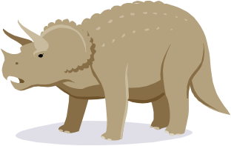
DINOSAURS!
Were they real?

Science Standards:
Explain how fossils provide evidence about the nature of ancient life. (III.4 benchmark 1)

Concepts & Principles that support the Standards:
Fossils are proof that dinosaurs were part of creation and lived during the time of the flood and Noah’s Ark.

Objectives:
TLW replicate a fossil print by pressing an object into clay
TLW Show that the Bible gives information about dinosaurs. (Ken Ham)
TLW Tell how different dinosaurs protected themselves from predators, and survived while they were in existence.
PURPOSE:
To give children an idea about who dinosaurs were and when they lived, and why and how they went extinct.
ENGAGE: | Jurassic Park theme music will be playing as the students walk in and the teacher will be wearing a safari hat and khakis.  (Have several different dinosaurs laid out on the desk so that when the students are learning about the importance of protection they can see visually how the dinosaurs used certain body parts to protect themselves.[ Stegosaurus, T-Rex, Pterodactyl, and Triceratops.])  Hold up a bone after everyone is seated and ask them what they think it is and from what animal it could have possibly come from. (Make sure this is a rather large bone) Build upon the answers by asking where they might have seen a bone like this or what the animal it belonged to looked like.
Exploration: | At each table set out some clay, and several flat objects that have definite shapes, ridges, and designs in them. These items will become fossilized in the clay.  Show the students what they will be doing by modeling a quick example:  - Take a piece of clay about the size of a tennis ball  - Roll the piece of clay into a ball and then flatten it (Make sure the student’s don’t flatten it too much; keep to a thickness about the width of your thumb.)  - Have the student’s pick an object and press it into the clay.  - Gently remove the object, (this may require some teacher help if an object got to imbedded in the clay.)
Explanation: | Ask the students what they see in their clay. “What shape is your imprint? “Can you tell what your imprint is, just by looking at it and not at the object you used?”  Ask if they know what the imprint is called: “Fossil”  Give the definition of a fossil – “the remains, prints, or traces of plants and animals that lived long ago. Fossils are found embedded in rocks or other materials that form the earth’s crust.”  Can someone tell me what kind of fossils we see in the museums? Are there any big fossils that are animal like and lived a long time ago? The student’s should be able to make the distinction between fossil and dinosaur rather quickly, based on the materials around the room, the bone, and the fossilization project. (Have the student’s clear their area, and set their projects on a piece of paper with their name written in the corner. Set them aside.)
Elaborate: | (Have students sit in a circle on the floor.)  *In the Bible the word “Leviathan” means terrible lizard, many Christian scientists believe that these lizards were in actuality dinosaurs. According to Mr. Ken Ham, a creationist, he believes that dinosaurs were created with the rest of the animals and even went on Noah’s ark: (show picture here from Ken Ham’s book of the drawing of Noah’s ark and have the student’s find the dinosaurs pictured in the artwork. Can someone tell me the name of the dinosaur seen? – Brontosaurus )  A lot of people don’t know if there were dinosaurs, and some believe that the bones belonged to some kind of animal but not dinosaurs, they think dinosaurs are the imagination of{ Paleontologists –those are people who study fossils.}  Give the children some of the dinosaur statues,  (Dinosaurs had ways of protecting themselves from predators, do you notice anything about you dinosaur that would make a good weapon against an attacking enemy?) (Stegosaurus – has spikes on the end of it’s tale to swing at a predator) (Pterodactyl – wings so they could fly from predators) (Triceratops – horns on its head to ram into predator)
Evaluate: | Evaluate the students by having them talk about what they learned today, ask them what a fossil and paleontologist are and/or what they do. Do they think dinosaurs are real or fake? Why or Why not?  Have them find one book on dinosaurs, and with their parents reading to them, have them discuss the Christian belief that if dinosaurs did live it wasn’t billions and millions of years ago, and talk about some reasons there aren’t any dinosaurs in existence today.  Another option is to take a field trip or visit to a museum and look at the fossils and then orally tell about the experience.
* denotes material taken from Ken Ham’s book about Dinosaurs.

Title:
- Conclusion: Wrapping Up Life

Subject/Grade Level:
- Living vs Non-living
- Kindergarten – 1st Grade

Rationale/Purpose:
- Activities that Evaluated what the students learned during the “Gone Froggy”, “Adventure in the Rainforest”, and “It is Alive” lessons
- Standard III.5- Ecosystems
- L.OL.00.20

Objectives:
- The student will be able to rephrase what all living things need to maintain their existence
- The student will be able to recall the difference between living and non-living organisms
- The student will be able to classify organisms and animals based on their characteristics

Content:
- The rainforest is made up of four layers which each contain living and non-living things.
- The life cycle of living and non-living frogs. Characteristics of living and non-living frogs.
- A living organism needs food, air, water, sunlight, and a habitat to survive

Materials:
- Two paintings of a picture of the rainforest (the different levels)
- 2 Burlap Bags
- Mini Pool
- Bag of Leaves
- Various parts of a Frog
- Various parts of a life cycle
- Various parts of a habitat
- Six ice cream buckets
- Flash cards of pictures of live things
- Plants from previous lesson: those growing well and the others that were deprived of sun, water, etc

Strategies and Activities:
- Engage
  - Asking questions of what they learned from the previous lessons, what they found interesting, and what questions they still have.
- Explore
    - The student’s will be doing a relay race using Burlap bags. The students will divide into two groups and line up in a straight line. The first player on both teams will pull the burlap bags over their legs and on the count of 1, 2, 3, Go! They will promptly hop to the Bog “mini pool” and pull out from the bog various items that relate to Frogs and what they learned about the prior week. They will take the item and hop over to one of the two buckets by their team, correctly putting it into one of the two buckets that are labeled, Living and Non-Living. They will then scramble out of the burlap bag and pass it on to the next player who will repeat the process and the other player will move to the back of the line!
    - The students will be divided into two groups. Each of the groups will have the same pictures of living and non-living things (dirt, rocks, nest, ants, mice, snakes, leopard, spider monkeys, fruit bats, butterflies, fruit, toucan, parrot, sunlight). The two groups will compete at placing the pictures on the felt boards in the correct places (how high or how low in the rainforest they live and whether they are living or not) in the fastest amount of time.
- Explain
    - Once all the students have had a chance to race to the bog, we will gather the students together and go through each of the buckets to make sure the items were placed into the correct bucket, either living or non-living. We will discuss the items, why they were placed in each of the buckets.
    - Once all the of the items have been placed on the two rainforest paintings, we go through each of the pictures and discuss as a class why the items were placed where they were on the paintings.
- Evaluate
- When done we will look at the six buckets total and see what they remembered from the previous lesson and how they did.
- When done we will look at the felt boards and see what they remembered from the previous lesson and how they did.

Plans for Individual Differences:
- If there are some struggling students in the classroom, make sure to group them with a stronger student.
- The activity includes hands on and verbal.

- UNIT ASSESSMENT
Plans for Assessment of Unit Goals:
Within the lessons we used a series of different ideas to assess within our lessons, our last lesson was actually a compilation of the lesson learned and an overall assessment lesson that was more actively engaging than lecturing.
- At the end of each lesson, we ask questions about what the children learned from that lesson and how it applies to the idea of Living and Non-Living.
  - We give cue words within the questions. Ex. Look at Visuals and remember what was taught.
- Worksheets/Panel Boards
- Plant picture journals
- I learned statements on cards
- Activities- Bag hop
- Coloring pages
Ways to Receive Feedback:
For children they are always asking Why? So many of the ways we received feedback were through questions and journals that were drawn during the rest of the week. We also received a lot of feedback as they walked into the classroom and when they left for the day.
- I learned statements
- Questions and Answer time
- Circle Time
- Use of Visuals to bring out ideas and answers

